**Discuss the evolution of privacy and security concerns with the advancement of networked technologies ?**

**1 Definition:**

* + - Privacy is about Networked Technologies means keeping your personal information and computer systems safe from people who shouldn’t see, use, or change them.
    - Third-Party Sharing Organizations should be transparent about sharing personal data with third parties.
    - Security This becomes more important as more devices (like phones, laptops, or smart gadgets) are connected to each other through the internet.
    - This includes using strong passwords, enabling two-factor authentication, and being cautious about the information shared on social media and other online platforms

**2. Diagram:**

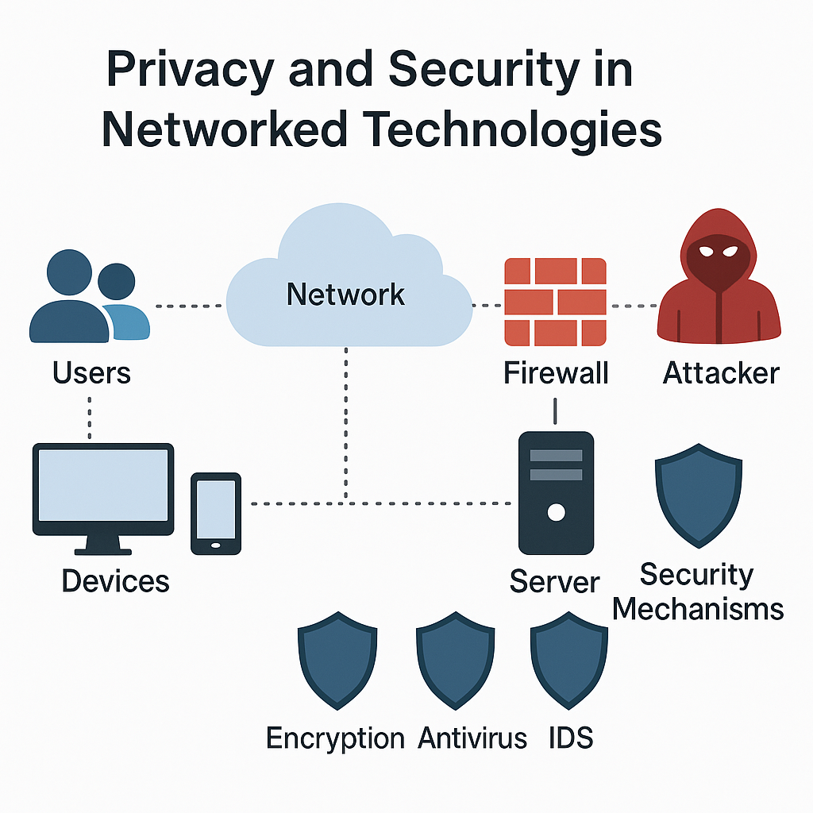

3**. Key Components:**

* **Users or Clients:** who use phones, computers, or other devices to go online and use apps or websites. They might use things like social media, cloud storage, or smart devices.
* **Devices** : Gadgets like desktops, laptops, smartphones, tablets, smart TVs, IoT gadgets (like smart lights, smartwatches), and even embedded systems. Each device is a potential entry point for cyber threats if not properly secured.
* **Network** : The backbone of communication. It includes local area networks (LAN), wide area networks (WAN), and the Internet. Routers, switches, and modems are network devices.
* **Servers**: These are powerful computers or cloud systems that deliver services and store large volumes of data. They run applications like websites, databases, email systems, etc.
* **Security Tools**: Tools and technologies designed to defend systems and data

1. **Firewalls** – Block unauthorized access
2. **Antivirus/Anti-malware** – Detect and remove malicious software
3. **Authentication Systems** – Control who logs in (passwords, biometrics, 2FA)
4. **Encryption** – Secure data during transfer or storage

* **Data:** The most valuable asset. It includes personal info (names, addresses, bank details), business data (contracts, IP, emails), and system data (logs, configurations).

**4 .Working Process:**

1. **Data Collection**: Organizations collect data through various means, including

* **Cookies**: Small files stored on users' devices to track their online behavior and preferences.
* **Tracking Technologies**: Tools like web beacons and pixel tags that monitor user interactions on websites.
* **Third-Party Data**: Purchasing data from data brokers or aggregators to enhance user profiles.

1. **Data Storage**: Information is stored in databases, often in cloud environments, which can introduce risks related to unauthorized access

**Types of Storage:**

* + On-Premises Databases: Data stored on local servers managed by the organization.
  + Cloud Storage: Data stored on remote servers managed by third-party cloud service providers.

1. **Data Processing:**

* Decision-Making using Data can be helps businesses make better decisions that lead to success.
* Performance Improving the processes can save time and money, boosting overall productivity.
* Customer Understanding the customers helps businesses create better products and targeted marketing, leading to happier customers.
* Risk Management can be Identifying potential problems that could harm the business to take action to prevent issues, protecting their assets and reputation.

1. **Data Protection Measures:**

* **Encryption:** Converting data into a coded format to prevent unauthorized access during transmission and storage.
* **Access Controls:** Implementing user authentication and authorization protocols to restrict data access to authorized personnel only.
* **Regular Audits**: Conducting periodic reviews of data handling practices and security measures to identify vulnerabilities and ensure compliance.

1. **Data Sharing**:
   * **Internal Sharing**: Sharing data among different departments within the organization for operational purposes.
   * **External Sharing**: Sharing data with third parties (e.g., partners, vendors) while ensuring that data sharing agreements are in place to protect user privacy.
   * **User Consent**: Obtaining explicit consent from users before sharing their data with third parties.
2. **Monitoring and Detection**:
   * **Intrusion Detection Systems (IDS)**: Tools that monitor network traffic for suspicious activities and potential breaches.
   * **Security Information and Event Management (SIEM)**: Systems that aggregate and analyze security data from various sources to detect threats in real-time.
   * **User Behavior Analytics (UBA)**: Monitoring user activities to identify anomalies that may indicate security threats.

**7. Advantages of Networked Technologies in Security:**

* **Centralized Monitoring**: Easier to manage through cloud-based tools.
* **Automated Threat Detection** using AI and machine learning.
* **Real-time Updates & Patches** to fix vulnerabilities.
* **Access from Anywhere**: Facilitates remote work with secure VPNs.

**8. Disadvantages / Challenges:**

* **Increased Attack Surface**: More connected devices = more entry points.
* **Sophisticated Cyber Threats**: Advanced persistent threats (APTs), ransomware.
* **Data Privacy Issues**: Surveillance capitalism, data leaks.
* **Complexity of Management**: Difficult to secure hybrid infrastructures (cloud + on-premise).

**Conclusion:**

As networked technologies continue to evolve, privacy and security must adapt through stronger regulations (e.g., GDPR), better technologies (e.g., zero trust architecture), and increased user awareness. The balance between innovation and protection is crucial in the digital age.